**Methodology for estimation of soil physical properties for hydrologic modeling in Arequipa, Peru**

Fariborz Daneshvar1, Jane R. Frankenberger1, Laura C. Bowling2, Keith A. Cherkauer1, Martín Juan C. Villalta Soto3

1Agricultural and Biological Engineering Department, Purdue University, West Lafayette, IN USA

2Agronomy Department, Purdue University, West Lafayette, IN USA

3Facultad de Agronomía, Universidad Nacional de San Agustín, Arequipa, Peru

Table of Contents

1. Introduction: 2

2. Available soil data 3

2.1. Soil Maps of Arequipa Region 3

2.2. Soil profile data 5

3. Selecting soil profiles for each polygon of the map 10

3.1. Identify distribution of soil taxonomies and suitability for the target watershed. 10

3.2. Select representative soil profiles for each taxonomy/suitability category 12

3.3. Calculate average soil profiles in case of having more than one profile for a taxonomy/suitability combination 13

3.4 Quantify rock fragments 14

3.5. An Example for one map unit (Typic Haplustands/P3se) 14

4. Estimating remaining soil properties required by SWAT 16

4.1. Hydrologic properties (SOL_BD, SOL_AWC and SOL_K) 16

4.2. Maximum rooting depth of soil profile 17

4.3. USLE equation soil erodibility (K) factor of top layer 17

4.4. Moist soil albedo of top layer 18

4.5. Soil Hydrologic group (A,B,C,D) 18

5. Sample Results 20

6. References: 21

Appendix 1. Suitability codes definition 22

Appendix 2. List of available soil profiles for six dominant taxonomies in El Frayle 23

Appendix 3. Equations developed by Saxton and Rawls to estimate three hydrologic properties 25

# 1. Introduction:

Hydrologic models including the Soil and Water Assessment Tool (SWAT) require maps of spatially distributed physical properties of soil (e.g. texture, hydraulic conductivity, etc.) that are only available for specific points in Arequipa. This methodology has been developed to extract or estimate these properties as a continuous map layer from available soil data. There are two maps of soil taxonomy and suitability available for the Arequipa region. We also have the original soil profile data used to develop these two maps. This report explains how the soil profile data was used to obtain soil physical properties for each map unit (Figure 1). Section 2 of this document explores the available soil data, then in Section 3 the approach for selection and averaging of representative soil profiles is explained. In Section 4, the process to calculate the remaining physical properties needed for SWAT is described, while Section 5 illustrates a completed table of combined taxonomy/suitability.

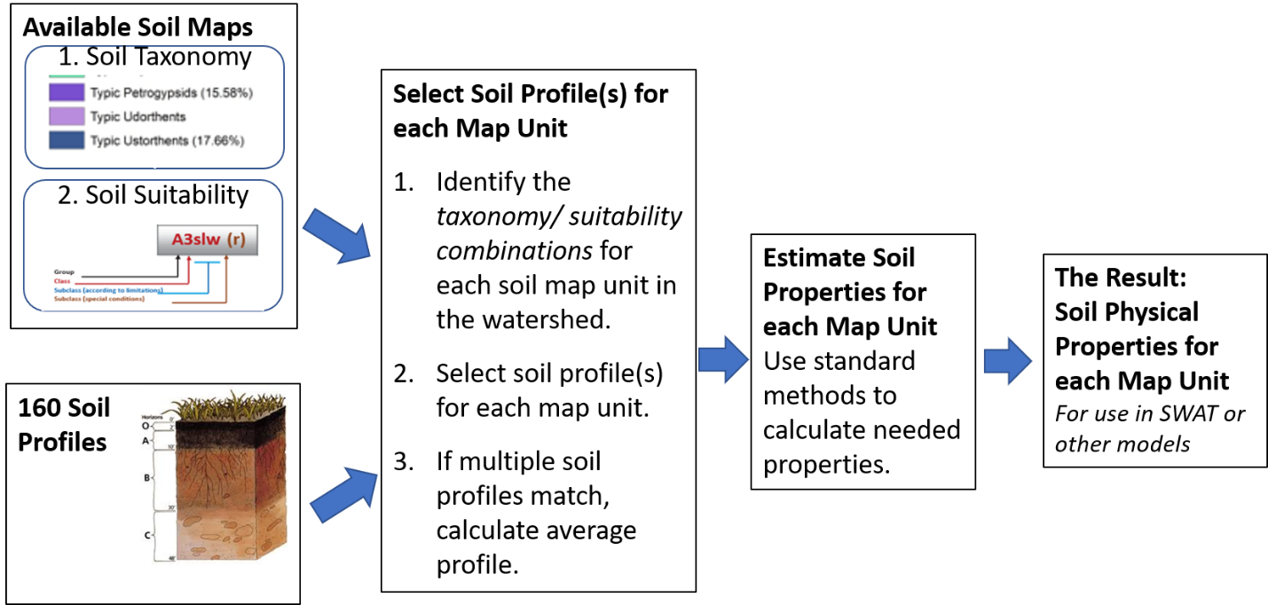

*Figure 1. Steps for calculation of soil physical properties*

# 2. Available soil data

## 2.1. Soil Maps of Arequipa Region

There are two soil maps for the Arequipa Region, created for the Ecological and Economic Zoning (Zonificación Ecológica y Económica or ZEE) conducted by the Ministry of Environment (Ministerio de Ambiente) for all regions of Peru [1,2]. Both have the same 5175 polygons, with map unit code that is a common field between them.

1. Soil Taxonomy (Figure 2). Provides order (e.g Andisols), sub-order (e.g. Ustands), group (e.g. Haplustands) and subgroup (e.g. Typic Haplustands) of soil taxonomy for each map unit code (e.g. CONSOCIACIÓN MISAHUANA MAURAS - MM).

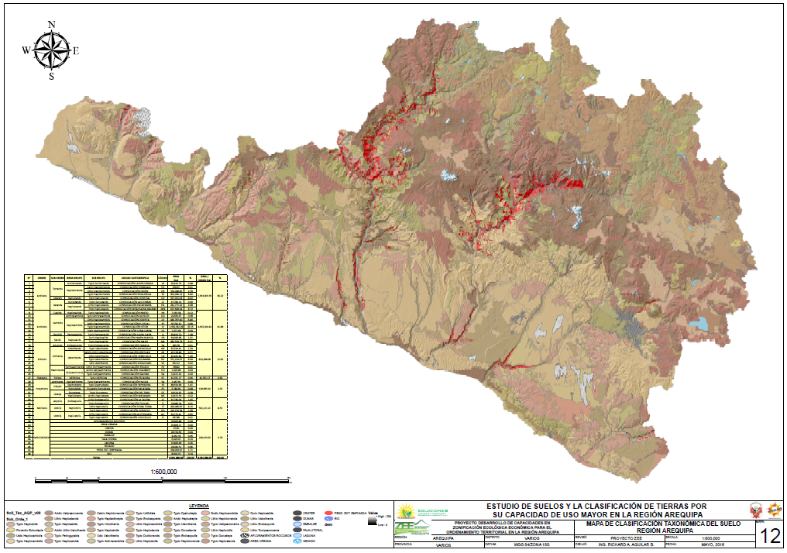

Figure 2. ZEE map of soil taxonomy for Arequipa Region [1]

1. “Capacidad de uso mayor”, which we translate to English as “Soil suitability” (Figure 4). This map addresses suitability for cultivation, pasture, forest, or protection, based on limitations due to soil, salt, erosion risk, drainage, flood risk, and weather (described in Appendix 2)

Figure 3. The levels of suitability classification [1]. Classes are described in Appendix 1

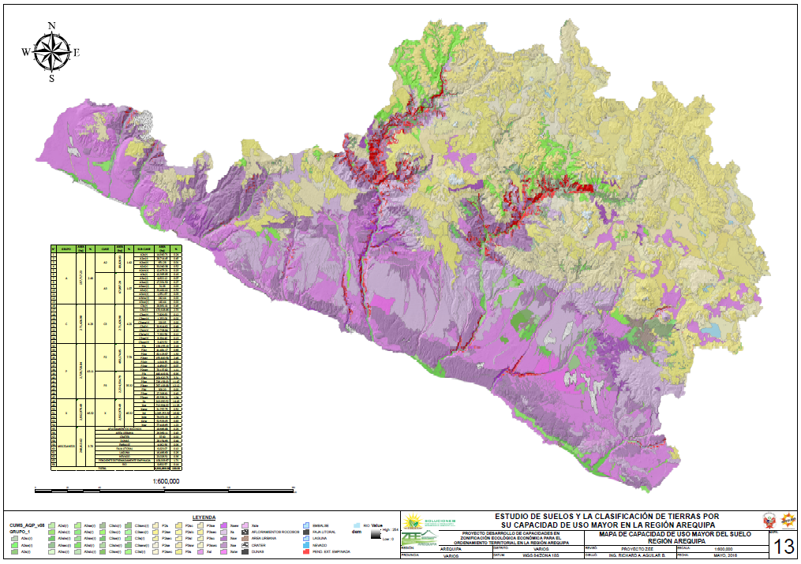

Figure 4. ZEE map of Soil Suitability for the Arequipa Region [1]

All codes in Figures 2 and 4 (including suitability codes) are explained in the ZEE report [1]. Description of suitability codes from chapter five of the ZEE report are available in Appendix 1 of this document.

## 2.2. Soil profile data

Profile data for 160 soil profiles in the Arequipa Region (Figure 5) are available from the ZEE report. For each soil profile, taxonomy, suitability, site observations and lab results of mechanical and chemical analysis are available in Appendices 2, 4 and 5 of the ZEE report. Tables 1 and 2 show available data for one soil profile (CAL 23) as an example.

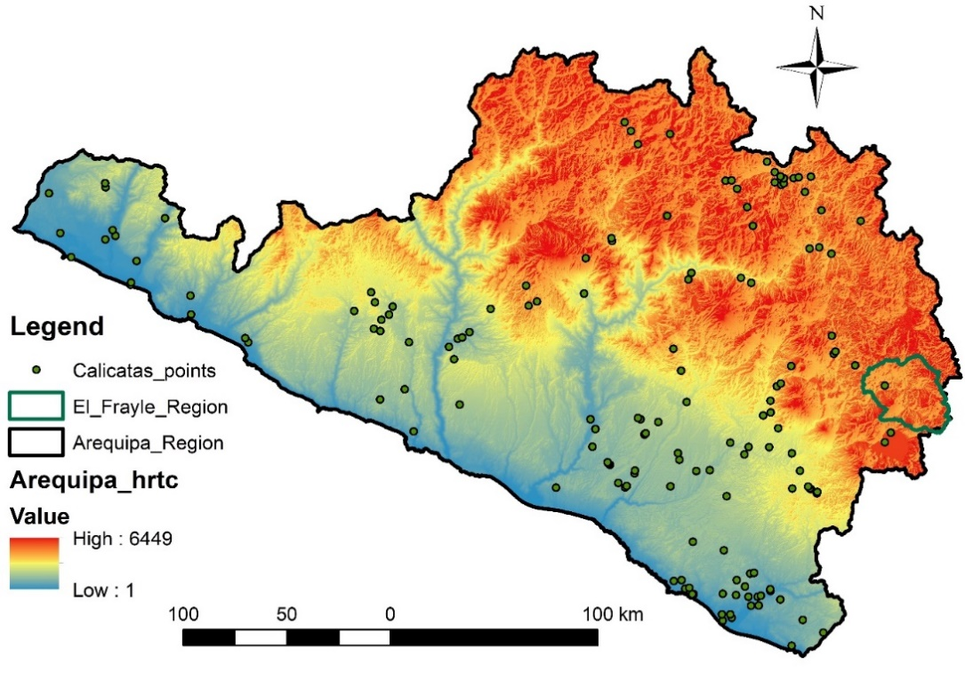

Figure 5. Locations of the soil profiles used for ZEE maps development

Table 1. Data available for a soil profile (CAL 23) from Appendix 5 of the ZEE report [1] (Spanish in parentheses)

|  |  |  |  |  |  |
| --- | --- | --- | --- | --- | --- |
| **Date:** | | | 06/19/2016 | | |
| **1. Classification (Clasificación)** | | |  | | |
|  | | | USDA (2010): Typic Haplustands | | |
|  | | | Diagnostic horizon (Horizonte diagnóstico): Ócrico | | |
| **2. Location (Ubicación)** | | |  | | |
| Spatial system (Sistema Espacial): | | | UTM, WGS 84, 18 S | | |
| Region (Región): | | | Arequipa | | |
| Province (Provincia): | | | Caylloma | | |
| District (Distrito): | | | Maca | | |
| Place (Lugar): | | | Maca | | |
| Coordinates (Coordenada) | | |  | | |
|  | | | X (east): 848,077 m | | |
|  | | | Y (north): 8,266,245 m | | |
|  | | | Altitude: 3537 msnm | | |
| **3. Geomorphology (Geomorfologia)** | | |  | | |
| Morphological unit (Unidad morfológica): | | | Steeply dissected steep slopes (Laderas escarpadas intensamente disectadas) | | |
| General slope (Pendiente general): | | | Steep (Empinada) (15 – 25 %) | | |
| Local slope (Pendiente local): | | | Very steep (Muy Empinada) | | |
| Geology-Parental Material (Geología-Material Parental): | | | Upper Muddy Event (Evento Barroso superior) | | |
| **4. Land use and vegetation (Uso de la tierra y vegetación)** | | | | | |
| Land use (Uso de la tierra): | | | Agricultural (Agrícola) | | |
| Crops (Cultivos): | | | Alfalfa and fallow (Alfalfa y en Descanso) | | |
| Human Influence (Influencia humana): | | | Yes - Agriculture and Livestock (Si - Agricultura y Ganadería) | | |
| Natural vegetation (Vegetación natural): | | | Eucalyptus, Cactaceae, Grasses and Chilca (Eucalipto/Eucaliptus, Cactáceas, Gramíneas y Chilca) | | |
| **5. Surface characteristics (Caracteristicas de la superficie)** | | | | | |
| **Rock outcrop (Afloramiento rocoso)** | | | | | |
| Coverage (Cobertura) | | | Little (Poca) | | |
| Distance outcrops (Distancia afloramientos) [m] | | | > 50 | | |
| Hardness (Dureza): | | | Hard (Duro) | | |
| **Rock fragments (Fragmentos gruesos)** | | | | | |
| Size classes (Clases de tamaño): | | | Stones (Piedras) | | |
| Coverage (Cobertura): | | | Frequent (Frecuente) | | |
| Hardness (Dureza): | | | Hard (Duro) | | |
| **Erosion (Erosión)** | | |  | | |
| Category (Categoría): | | | Water and wind erosion (Erosión Hídrica y Eólica) | | |
| Area (Superficie) [%]: | | | > 50 | | |
| Grade (Grado): | | | Light (ligero) | | |
| **Encountering (Crusting)** | | |  | | |
| Thickness (Grosor): | | | None (Ninguno) | | |
| Consistency (Consistencia): | | | - | | |
| **Cracks (Grietas):** | | |  | | |
| Width (Ancho): | | | None (Ninguno) | | |
| Distance between cracks (Distancia entre grietas): | | | - | | |
| Depth (Profundidad): | | | - | | |
| **6. Profile characteristics (Caracteristicas del perfil)** | | | | | |
| Effective depth (Profundidad efectiva): [cm] | | | 150 | | |
| Type (Tipo) [Porta, J., 2005]: | | | Deep (Profundo) | | |
| **Permeability (Permeabilidad)** | | |  | | |
| Runoff (Escorrentía): | | | Normal | | |
| Natural drainage (Drenaje natural) [FAO 2009]: | | | Good (Bueno) | | |
| **Water table (Nivel freatico)** | | |  | | |
| Depth (Profundidad): | | | No Evidence (Sin Evidencia) | | |
| **7. Photos of the profile or land (Fotos del perfil o barrenación):** | | | | | |
|  | | | | |  |
| Panorama (Panorámica) | | | | | Profile (Perfil) |
| **8. Description of horizons or layers (Descripción de horizontes o capas):** | | | | | |
| Horizon or layer  (Horizonte o capa) | Depth (Profundidad) [cm] |  | | | |
| A | 0-25 | English:  Sandy loam texture; color 7.5YR 6/3 (light brown) dry, 7.5YR 2.5 / 2 (very dark brown) wet; Granular structure, very thin / thin, weak; Consistency: loose, non-adherent, no dry and wet plastic; The horizon is dry; Presents common porosity, half irregularly shaped; Middle roots, common; It presents channels and nests of termites or ants with little abundance; Presence of stones, fresh or slightly weathered in 30% of the horizon; Positive NaF reaction; Limit the abrupt horizon, smooth; neutral pH (7.02); Slightly saline (1.29 mS / cm); Non-calcareous (0.0%); Very low content of organic matter (0.42%); Very low nitrogen content (0.020%); High phosphorus content available (24.07 ppm); high on available potassium (420 ppm); Low exchangeable calcium content (5.04 meq / 100 g soil); Low exchangeable magnesium content (1.02 meq / 100 g soil); Very high exchangeable potassium content (1.07 meq / 100 g soil); exchangeable sodium content medium (0.16 meq / 100 g soil); Low cation exchange capacity (7.4 meq / 100 g soil); high percentage of base saturation (100%); non-sodium soil (2.16% PSI).  Spanish:  Textura franco arenoso; color 7.5YR 6/3 (marrón claro) en seco, 7.5YR 2.5/2 (marrón muy oscuro) en húmedo; Estructura granular, muy fino/delgado, débil; Consistencia: suelto, no adherente, no plástico en seco y húmedo; El horizonte está seco; Presenta  porosidad común, medio en forma irregular; Raíces medias, comunes; Presenta canales y nidos de termitas u hormigas con poca abundancia; Presencia de piedras, fresco o ligeramente intemperizado en el 30% del horizonte; Reacción al NaF positivo; Limite del horizonte abrupto, suave; pH neutro (7.02); Ligeramente salino (1.29 mS/cm); No calcáreo (0.0%); Muy bajo contenido de materia orgánica (0.42%); Muy bajo contenido de nitrógeno (0.020%); Alto contenido en fosforo disponible (24.07 ppm); alto en potasio disponible (420 ppm); Bajo contenido de calcio cambiable  (5.04 meq/100 g suelo); Bajo contenido en magnesio cambiable (1.02 meq/100 g suelo); Muy alto contenido en potasio cambiable (1.07 meq/100 g suelo); Medio contenido en sodio cambiable (0.16 meq/100 g suelo); Baja capacidad de intercambio catiónico (7.4 meq/100 g suelo); alto porcentaje de saturación de bases (100%); suelo no sódico (2.16% PSI). | | | |
| AC | 25-150 | English:  Sandy loam texture; 10YR color 6/3 (pale brown) dry, 10YR 4/2 (dark grayish brown) wet; Grain structure simple; Consistency: loose, non-adherent, non-dry plastic and damp; The horizon is dry; It has common porosity, very fine in tubular channels; Medium roots, few; Presence of stones and songs, fresh or slightly weathered in 50% of the horizon; Reaction to negative NaF; Slightly alkaline pH (7.80); Non saline (0.11 mS / cm); Non-calcareous (0.0%); Very low content of organic matter (0.48%); Very low nitrogen content (0.025%); Low phosphorus content available (6.28 ppm); Low on available potassium (90 ppm); exchangeable calcium content (5.97 meq / 100 g soil); exchangeable magnesium content (1.16 meq / 100 g soil); exchangeable potassium content (0.28 meq / 100 g soil); Low exchangeable sodium content (0.19 meq / 100 g soil); Low cation exchange capacity (7.6 meq / 100 g soil); high percentage of base saturation (100%); non-sodium soil (2.50% PSI).  Spanish:  Textura franco arenoso; color 10YR 6/3 (marrón pálido) en seco, 10YR 4/2 (marrón grisáceo oscuro) en húmedo; Estructura grano simple; Consistencia: suelto, no adherente, no plástico en seco y húmedo; El horizonte está seco; Presenta porosidad común, muy fino en canales tubulares; Raíces medias, pocas; Presencia de piedras y cantos, fresco o ligeramente intemperizado en el 50% del horizonte; Reacción al NaF negativo; pH ligeramente alcalino (7.80); No salino (0.11 mS/cm); No calcáreo (0.0%); Muy bajo contenido de materia orgánica (0.48%); Muy bajo contenido de nitrógeno (0.025%); Bajo contenido en fosforo disponible (6.28 ppm); Bajo en potasio disponible (90 ppm); Medio contenido de calcio cambiable (5.97 meq/100 g suelo); Medio contenido en magnesio cambiable (1.16 meq/100 g suelo); Medio contenido en potasio cambiable (0.28 meq/100 g suelo); Bajo contenido en sodio cambiable (0.19 meq/100 g suelo); Baja capacidad de intercambio catiónico (7.6 meq/100 g suelo); alto porcentaje de saturación de bases (100%); suelo no sódico (2.50% PSI). | | | |
| **9. Climatic information (Información climática):** | | | | | |
| Moisture regime (Régimen de Humedad) | | | | Ústico | |
| Temperature Regime (Régimen de Temperatura): | | | | Isomesico | |
| Life Zone (Zona de Vida): | | | | Estepa - Montano Subtropical | |
| **10. Erosion susceptibility (Susceptibilidad a la erosion)** | | | | | |
| Susceptibility (Susceptibilidad) | | | | Light (Ligero) | |
| **11. Suitability (CAPACIDAD DE USO DE USO MAYOR DEL SUELO-CUMS):** | | | | | |
| P3swc: | | | English:  Lands suitable for pastures with low agrological quality and soil limitation (low fertility) and topography (high slope, erosion).  Spanish:  Tierras aptas para pastos con calidad agrologica baja y limitación por suelo (baja fertilidad) y topografía (elevada pendiente, erosión). | | |
| **12. Other observations (Otras observaciones)** | | | | | |
|  | | | English: Anthropogenic Activity Agricultural productions on platforms. Landscape with gullies and grooves, steep slopes and laminar erosion.  Spanish:  Actividad Antropogénica. Producciones agrícolas en andenes. Paisaje con cárcavas y surcos, laderas empinadas y erosión laminar | | |

Table 2. Lab results for a soil profile (CAL 23) from Appendix 4 of the ZEE report [1]

|  |  |  |  |  |  |  |  |  |  |  |  |
| --- | --- | --- | --- | --- | --- | --- | --- | --- | --- | --- | --- |
|  | Mechanical analysis | | | | Chemical analysis | | | | | Available elements | |
| Profiles | Sand  [%] | Clay  [%] | Silt  [%] | Texture | CO3Ca  [%] | PH | E.C.  [mS/cm] | OM  [%] | N  [%] | P  [ppm] | K  [ppm] |
| Layer#1 | 74.2 | 4.6 | 21.2 | Sandy loam | 0.0 | 7.02 | 1.29 | 0.42 | 0.02 | 24.07 | 420 |
| Layer#2 | 71.2 | 4.6 | 24.2 | Sandy loam | 0.0 | 7.80 | 0.11 | 0.48 | 0.025 | 6.28 | 90 |

C.E.: Electrical conductivity; OM: Organic matter; N: Nitrogen; P: Phosphorus; K: Potassium; mS/cm: millisiemens per centimeter; ppm: Parts per million

# 3. Selecting soil profiles for each polygon of the map

The following methodology was developed to map soils for all of the Arequipa Region, but is presented here for the El Frayle River Basin (shown in Figure 5) as an example.

## 3.1. Identify distribution of soil taxonomies and suitability for the target watershed.

Soil taxonomy for the El Frayle watershed is shown in Figure 5 and listed in Table 3.

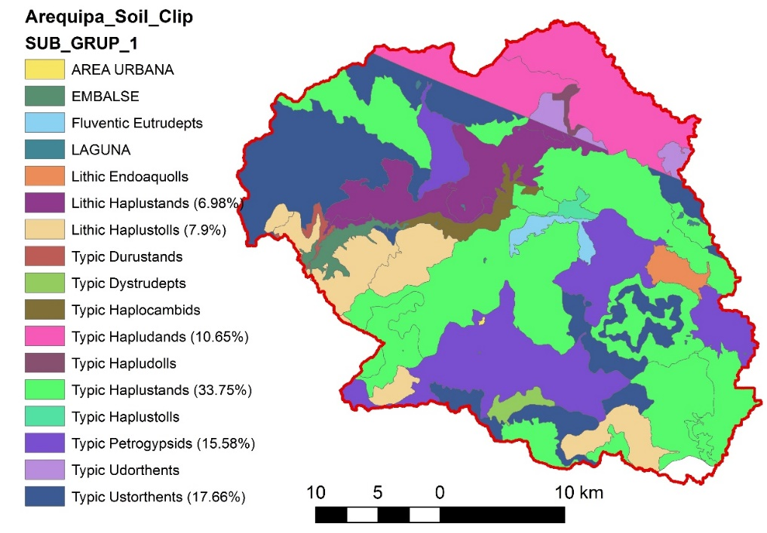

Figure 6. Soil taxonomy of El Frayle

Table 3. Soil taxonomy of El Frayle watershed (soils with more than 5% coverage are shown in bold. These six map unit codes are examined further in this report to illustrate the method.)

|  |  |  |  |  |  |  |  |
| --- | --- | --- | --- | --- | --- | --- | --- |
| **Order** | **Sub order** | **Big group** | **Sub group** | **Cartographic unit** | **Map Unit Code** | **Area (km2)** | **%** |
| **Andisols** | **Udands** | **Hapludands** | **Typic Hapludands** | **Consociación Confital** | **CO** | **108.66** | **10.65** |
| Andisols | Ustands | Durustands | Typic Durustands | Consociación Las Zorras | LZ | 3.66 | 0.36 |
| **Andisols** | **Ustands** | **Haplustands** | **Lithic Haplustands** | **Consociación Patapampa** | **PA** | **71.21** | **6.98** |
| **Andisols** | **Ustands** | **Haplustands** | **Typic Haplustands** | **Consociación Misahuana Mauras** | **MM** | **344.31** | **33.75** |
| Aridisols | Cambids | Haplocambids | Typic Haplocambids | Consociación Vítor | VI | 14.30 | 1.40 |
| **Aridisols** | **Gypsids** | **Petrogypsids** | **Typic Petrogypsids** | **Consociación Llapa Llapa** | **LL** | **158.93** | **15.58** |
| Entisols | Orthents | Udorthents | Typic Udorthents | Consociación Antacollo | AN | 12.31 | 1.21 |
| **Entisols** | **Orthents** | **Ustorthents** | **Typic Ustorthents** | **Consociación Solimana** | **SO** | **180.11** | **17.66** |
| Inceptisols | Udepts | Dystrudepts | Typic Dystrudepts | Consociación Sepregina | SE | 6.65 | 0.65 |
| Inceptisols | Udepts | Eutrudepts | Fluventic Eutrudepts | Consociación Pacatara | PC | 8.95 | 0.88 |
| Mollisols | Aquolls | Endoaquolls | Lithic Endoaquolls | Consociación La Calera | LC | 10.68 | 1.05 |
| Mollisols | Udolls | Hapludolls | Typic Hapludolls | Consociación Hornillo | HO | 3.07 | 0.30 |
| **Mollisols** | **Ustolls** | **Haplustolls** | **Lithic Haplustolls** | **Consociación Acoypampa** | **AC** | **80.59** | **7.90** |
| Mollisols | Ustolls | Haplustolls | Typic Haplustolls | Consociación Ichucollo | IC | 4.38 | 0.43 |
| Miscellaneous | | Urban area | | | | 0.21 | 0.02 |
| Miscellaneous | | Reservoir | | | | 11.02 | 1.08 |
| Miscellaneous | | Lagoon | | | | 0.99 | 0.10 |

The map unit code (e.g. CO) is the common attribute in the two maps (taxonomy and suitability). Therefore, polygons from the suitability map that had the map unit code of dominant soil taxonomies in El Frayle (CO, PA, MM, LL, SO, AC that are bolded in Table 3) were selected and are listed in Table 4.

Table 4. Suitability variation among dominant taxonomy classes in El Frayle

|  |  |  |
| --- | --- | --- |
| **Taxonomy (% in El Frayle)** | **Map Unit** | **Suitability (% in taxonomy)** |
| Typic Haplustands (33.75%) | MM | P3sec (39%) |
|  |  | P3s (36%) |
|  |  | P3swc (16%) |
|  |  | P3se (8%) |
| Typic Ustorthents (17.66%) | SO | P2swc (95%) |
|  |  | P3sc (4%) |
|  |  | Xs (1%) |
| Typic Petrogypsids (15.58%) | LL | Xsl (100%) |
| Typic Hapludands (10.65%) | CO | P2sec (67%) |
|  |  | P3sec (33%) |
| Lithic Haplustolls (7.9%) | AC | P3sc (65%) |
|  |  | P3s (35%) |
| Lithic Haplustands (6.98%) | PA | P3sw (53%) |
|  |  | P3swc (47%) |

## 3.2. Select representative soil profiles for each taxonomy/suitability category

The soil profiles that match one of the six dominant taxonomies (defined as mapping to more than 5% of the area) in El Frayle (listed in Table 4) were selected. The following criteria were used to filter profiles with missing or inaccurate information:

* Profile summary information available from Appendix 5 of the ZEE report
* Lab results available from Appendix 4 of the ZEE report
* Given coordinates fall in a polygon with the same soil taxonomy (from Figure 2)
* Given coordinates fall in the same district as listed in the profile summary (Appendix 5 of the ZEE report)

The result was that 25 out of 38 profiles met these four criteria (shown in Table A.2) and were used for further analysis. Table 5 maps these 25 soil profiles to taxonomy/suitability combinations in El Frayle. (Note that the first 3 columns are the same as Table 2.)

***Note:*** For Soil Taxonomy/suitability combinations that did not have an observed soil profile, we used the following decision tree to select the most representative profile:

* Profiles with the same suitability group and class, but missing some of the subclass limitations were used, if available. If not,
* Profiles with the same suitability group and class, but different subclass limitations were used if any available. If not,
* Profiles with the same suitability group, but different class and common subclass limitations were used if any available. If not,
* Any profile with the given soil taxonomy was used.

For example, there was no soil profile with Typic Haplustands taxonomy and P3swc code. So, S001 was used. This is classified as Typic Haplustands and P3s.

Table 5. List of soil profiles associated with soil groups in El Frayle (First three columns are the same as Table 4)

|  |  |  |  |  |
| --- | --- | --- | --- | --- |
| **Taxonomy (% El Frayle)** | **CODE** | **Suitability**  **(% taxonomy)** | **Associated profile(s)** | **Alternate profile(s)** |
| Typic Haplustands (33.75%) | MM | P3sec (39%) | CA-14-Ancoyo |  |
|  |  | P3s (36%) | S001 |  |
|  |  | P3swc (16%) |  | S001 [P3s] |
|  |  | P3se (8%) | CAL 23* |  |
|  |  |  | CAL 42* |  |
| Typic Ustorthents (17.66%) | SO | P2swc (95%) |  | CAL 14 [P3se] |
|  |  | P3sc (4%) |  | CAL 14 [P3se] |
|  |  | Xs (1%) |  | CAL 04 [Xsl] |
|  |  |  |  | CAL 15 [Xswc] |
| Typic Petrogypsids (15.58%) | LL | Xsl (100%) | SC 12 |  |
| Typic Hapludands (10.65%) | CO | P2sec (67%) | M – 05 |  |
|  |  |  | M – 06 |  |
|  |  |  | M – 09 |  |
|  |  | P3sec (33%) | M – 02 |  |
|  |  |  | M – 03 |  |
|  |  |  | M – 10 |  |
|  |  |  | M – 13 |  |
|  |  |  | M – 14 |  |
|  |  |  | M – 29 |  |
| Lithic Haplustolls (7.9%) | AC | P3sc (65%) |  | CAL 55 [P3s] |
|  |  |  |  | CAL 58 [P3s] |
|  |  | P3s (35%) | CAL 55 |  |
|  |  |  | CAL 58 |  |
| Lithic Haplustands (6.98%) | PA | P3sw (53%) |  | CAL 53 [P3s] |
|  |  | P3swc (47%) |  | CAL 53 [P3s] |

* These profiles are used in examples of calculating parameters in following sections

## 3.3. Calculate average soil profiles in case of having more than one profile for a taxonomy/suitability combination

When more than one profile was available for one taxonomy-suitability combination, the profiles were combined using the slice-wise aggregation method (Figure 7) [3]. This has been used to calculate average values of soil profiles as visually explained in Figure 7 from Beaudette et al. [3]. Example of Slice-wise aggregation of percent sand for two profiles (CAL 23 and CAL 42) associated with Typic Haplustands/P3se (* in Table 3) is shown in Figure 8.

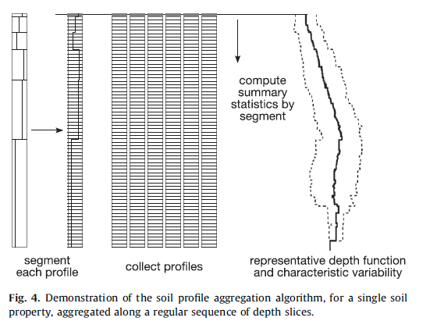

Figure 7. Slice-wise aggregation process (photo from Beaudette et al. [3])

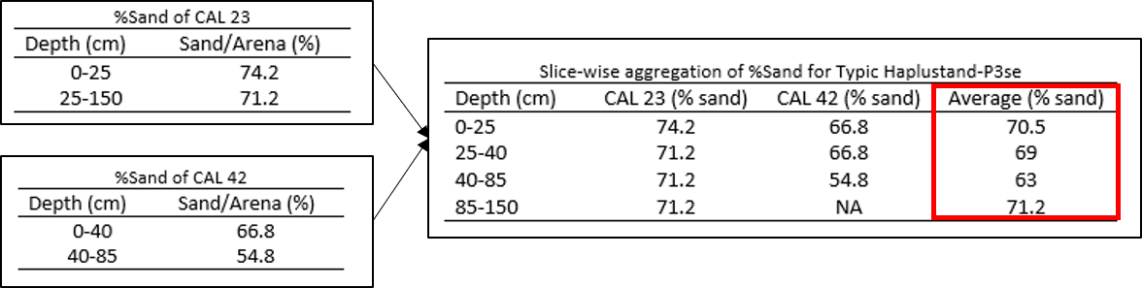

Figure 8. Slice-wise aggregated percent sand of two profiles ((CAL 23 and CAL 42) associated with Typic Haplustands/P3se (* in Table 3)

## 3.4 Quantify rock fragments

Percent rock fragment of all layers in addition to the overall percentage of rock fragments in the entire soil profile are reported in the site observation sheets (in Appendix 2 of the ZEE report). Only the overall rockiness classes are listed in Appendix 5 of the ZEE report and are classified in Table 6. SWAT requires percentage of rock for all layers, so in case of missing site observation sheets (in Appendix 2 of the ZEE report), the given value for a profile was used for all layers.

Table 6. Rockiness classification in the ZEE report

|  |  |  |
| --- | --- | --- |
| **Coverage/ cobertura** | **% (from Appendix 2)** | **Value used** |
| No rock/ Sin | 0 | 0 |
| Very few/ muy pocas | <10 | 5 |
| Few/ pocas | 10 – 25 | 17.5 |
| Frequent/ frequente | 25 – 50 | 37.5 |
| Abundant/ abundancia | 50 – 75 | 62.5 |
| Stony or rocky/ pedregoso o rocoso | >75 | 87.5 |

For few soil profiles, ranges of rockiness classes were different from Table 6 (e.g. Pocus: 2-5%) in which, similar to Table 6, the average of class range was used as the percentage of rock fragment for soil layers.

## 3.5. An Example for one map unit (Typic Haplustands/P3se)

To illustrate the procedure, Figure 9 demonstrates how it was used to calculate percent silt (%Silt), percent clay (%Clay), percent organic matter (%OM), percent rock (%Rock), and define the texture of slice-wise-aggregated profiles for Typic Haplustands/P3se combination. Calculation of percent sand (%Sand) using the slice-wise aggregated profiles is illustrated in Figure 8.

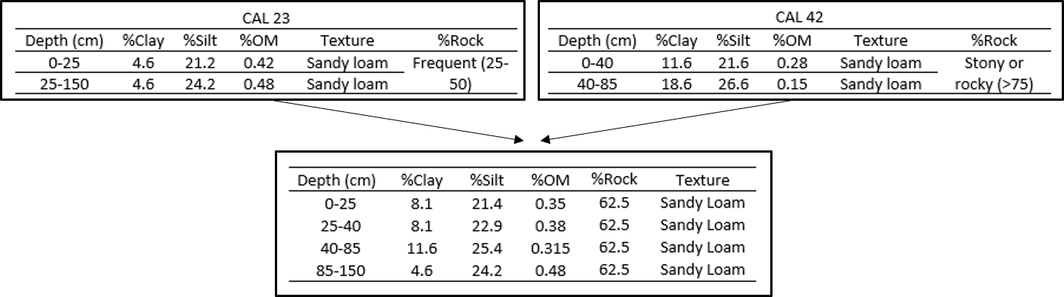

Figure 9. Slice-wise aggregated %silt, %clay, %organic matter, %rock and defined texture for Typic Haplustands/P3se combination

Results of this section were aggregated %sand, %silt, %clay, %rock, %organic matter and texture of existing soil profiles for all taxonomy/suitability combinations in Table 3. Table 7 shows the result for the Typic Haplustands/P3se combination

Table 7. Slice-wise aggregation of properties for soil profiles associated with Typic Haplustands/P3se

|  |  |  |  |  |  |  |
| --- | --- | --- | --- | --- | --- | --- |
| Depth (cm) | %Sand | %Clay | %Silt | %OM | %Rock | Texture |
| 0-25 | 70.5 | 8.1 | 21.4 | 0.35 | 62.5 | Sandy Loam |
| 25-40 | 69 | 8.1 | 22.9 | 0.38 | 62.5 | Sandy Loam |
| 40-85 | 63 | 11.6 | 25.4 | 0.315 | 62.5 | Sandy Loam |
| 85-150 | 71.2 | 4.6 | 24.2 | 0.48 | 62.5 | Sandy Loam |

***Note:*** SWAT requires percent organic carbon content (SOL_CBN). The following equation (recommended in the SWAT manual) was used to calculate SOL_CBN based on OM:

*SOL_CBN = OM / 1.72*

# 4. Estimating remaining soil properties required by SWAT

Soil properties required for SWAT are listed in Table 6. Bolded parameters are directly available from the ZEE report and were listed for one example in Table 7 in the previous section. The remaining parameters must be estimated and are explained in this section.

Table 8. List of soil properties required for SWAT [4]. (Bolded parameters are available as result of section#2)

|  |  |  |
| --- | --- | --- |
| **Properties** | **Name in SWAT** | **Unit** |
| **Number of layers (up to 10)** | **NLAYERS** | **NA** |
| **Texture** | **TEXTURE** | **NA** |
| **Depth from soil surface to bottom of each layer (up to 10)** | **SOL_Z** | **mm** |
| **Sand content of each layer (up to 10)** | **SAND** | **%** |
| **Silt content of each layer (up to 10)** | **SILT** | **%** |
| **Clay content of each layer (up to 10)** | **CLAY** | **%** |
| **Organic carbon content of each layer (up to 10)** | **SOL_CBN** | **%** |
| **Rock fragment content of each layer (up to 10)** | **ROCK** | **%** |
| Moist bulk density of each layer (up to 10) | SOL_BD | g/cm3 |
| Available water capacity of the soil layer of each layer (up to 10) | SOL_AWC | mm/mm |
| Saturated hydraulic conductivity of each layer (up to 10) | SOL_K | mm/hr |
| Maximum rooting depth of soil profile | SOL_ZMX | mm |
| USLE equation soil erodibility (K) factor of top layer | USLE_K | NA |
| Moist soil albedo of top layer | SOL_ALB | NA |
| Soil hydrologic group (A,B,C,D) | HYDGRP | NA |

## 4.1. Hydrologic properties (SOL_BD, SOL_AWC and SOL_K)

These three properties were estimated based on percent of sand, clay, rock and organic matter. The equations developed by Saxton and Rawls [5] to estimate SOL_BD, SOL_AWC and SOL_K are provided in Appendix 3. The SPAW (Soil-Plant-Atmosphere-Water Field & Pond Hydrology) program developed Dr. Keith E. Saxton, USDA-ARS [6] provides a visual interface that returns estimated hydrologic properties based on given inputs as shown in Figure 7.

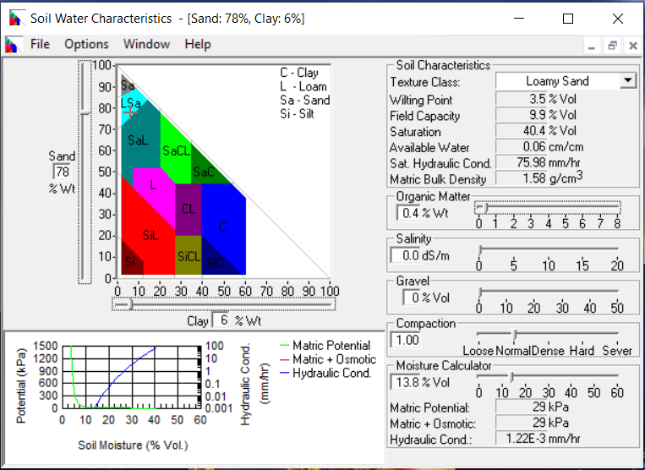

Figure 10. Screenshot of SPAW program interface

## 4.2. Maximum rooting depth of soil profile

The effective depth (profundidad efectiva) that is reported in Appendix 5 of the ZEE report was used as the maximum rooting depth of the soil profile.

In cases where effective depth was not provided, it was assumed that roots can develop throughout the entire depth of soil profile.

When more than one soil profile was available for a given taxonomy/suitability combination, the minimum effective depth of all profiles was used as the maximum rooting depth to avoid overestimation of rooting depth.

## 4.3. USLE equation soil erodibility (K) factor of top layer

The percent of sand, silt, clay and organic carbon of top layer were used to estimate USLE_K by Williams (1995) equation [7] (recommended in SWAT manual) as follow:

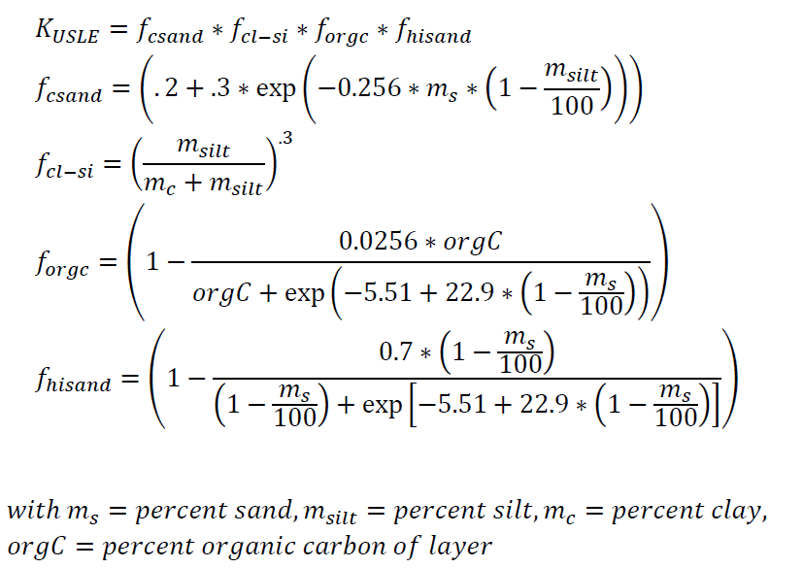

Where:

*fcsand*: is a factor that gives low soil erodibility factors for soils with high coarse-sand contents and high values for soils with little sand.

*fcl-si*: is a factor that gives low soil erodibility factors for soils with high clay to silt ratios.

*forgc*: is a factor that reduces soil erodibility for soils with high organic carbon content.

*fhisand*: is a factor that reduces soil erodibility for soils with extremely high sand contents.

*ms*: percent sand

*msilt*: percent silt

*mc*:percent clay

*orgC:* Percent of organic carbon

## 4.4. Moist soil albedo of top layer

Moist soil albedo was calculated based on color codes reported in Appendix 5 of the ZEE report. A linear regression developed by Post et al. [8](200) was used to calculate soil albedo based on the Chroma Meter Munsell color value:



The color value is the number that comes after YR and before “/”. For example, if a soil profile was coded as 7.5YR 2.5/2, the color value was 2.5.

In case of missing color value, albedo was set to be 0.13 (SWAT default value)

## 4.5. Soil Hydrologic group (A,B,C,D)

Soil hydrologic group was defined based on SOL_K of the least transmissive layer, and there are two sets of rules to define it based on SOL_K, depending on depth to an impermeable layer or water table [9]. Because depth to an impermeable layer or water table was not available, three criteria were used to determine which set of rules to use:

If any of the following exist:

1. Natural drainage class of the soil (listed in Appendix 5 of the ZEE report) is listed as Poorly drained/ Mal drenado, or
2. Soil profile depth is less than 100 cm (meaning that it reached impermeable layer), or
3. Soil taxonomy is classified as Lithic (e.g. Lithic Haplustands) meaning bedrock is at a shallow depth

Then, the rules for a shallow impermeable layer were used to estimate hydrologic group based on SOL_K of the least transmissive layer as follows:

* A: if SOL_K > 40 µm/s (5.67 in/h)
* B: if 10 µm/s (1.42 in/h) ≤ SOL_K < 40 µm/s (5.67 in/h)
* C: if 1.0 µm/s (0.14 in/h) ≤ SOL_K < 10 µm/s (1.42 in/h)
* D: if SOL_K ≤ 1.0 µm/s (0.14 in/h)

If the rules for a shallow impermeable layer do not apply, the following rules were used to estimate hydrologic group based on SOL_K of the least transmissive layer as follow:

* A: if SOL_K > 10 µm/s (1.42 in/h)
* B: if 4.0 µm/s (0.57 in/h) ≤ SOL_K < 10 µm/s (1.42 in/h)
* C: if 0.4 µm/s (0.06 in/h) ≤ SOL_K < 4.0 µm/s (0.57 in/h)
* D: if SOL_K ≤ 0.4 µm/s (0.06 in/h)

***Note:*** In case of having more than one soil profile, the first set of rules were used if at least one of the soil profiles met the criteria for shallow impermeable layer. If not, the second set of rules were used.

# 5. Sample Results

The final result was a set of soil properties for each soil taxonomy/suitability combination (listed in Table 4). Here are results for Typic haplustands/P3se combination.

Table 9. Final results for Typic Haplustands/P3se combination

|  |  |  |  |  |  |
| --- | --- | --- | --- | --- | --- |
|  | **Name [unit]** | **Value** | | | |
|  | NLAYERS | 4 | | | |
|  | TEXTURE | Sandy Loam, Sandy Loam, Sandy Loam, Sandy Loam | | | |
|  | HYDGRP | C | | | |
|  | SOL_ZMX [mm] | 400 | | | |
|  | USLE_K | 0.17 | | | |
|  | SOL_ALB | 0.18 | | | |
| 🡨 For each layer 🡪 | SOL_Z [mm] | 250 | 400 | 850 | 1500 |
| SAND [%] | 70.5 | 69 | 63 | 71.2 |
| SILT [%] | 21.4 | 22.9 | 25.4 | 24.2 |
| CLAY [%] | 8.1 | 8.1 | 11.6 | 4.6 |
| SOL_CBN [%] | 0.20 | 0.22 | 0.18 | 0.28 |
| ROCK [%] | 62.5 | 62.5 | 62.5 | 62.5 |
| SOL_BD [g/cm3] | 1.60 | 1.60 | 1.61 | 1.58 |
| SOL_AWC [mm/mm] | 0.04 | 0.04 | 0.05 | 0.04 |
| SOL_K [mm/hr] | 21.10 | 20.75 | 12.42 | 29.63 |

# 6. References:

[1] Gobierno Regional Arequipa, 2016. Elaboración del Estudio de Suelos y la Clasificación de Tierras por su Capacidad de Uso Mayor en la Región Arequipa. Proyecto Desarrollo de Capacidades en Zonificación Ecológica Económica para el Ordenamiento Territorial en la Región Arequipa, Autoridad Regional Ambiental de Arequipa, Gobierno Regional Arequipa, Arequipa, Perú. 1,152 pp. (Reg.# 1782331, Doc.# 1775929).

[2] MINAM, 2017. Zonificación Ecológica y Económica (ZEE). <https://www.minam.gob.pe/ordenamientoterritorial/zonificacion-ecologica-y-economica-zee/> (accessed 26.11.19)

[3] Beaudette, D.E., Roudier, P. and O'Geen, A.T., 2013. Algorithms for quantitative pedology: a toolkit for soil scientists. *Computers & Geosciences*, *52*, pp.258-268.

[4] Arnold, J.G., Kiniry, J.R., Srinivasan, R., Williams, J.R., Haney, E.B. and Neitsch, S.L., 2013. *SWAT 2012 input/output documentation*. Texas Water Resources Institute.

[5] Saxton, K.E. and Rawls, W.J., 2006. Soil water characteristic estimates by texture and organic matter for hydrologic solutions. *Soil science society of America Journal*, *70*(5), pp.1569-1578.

[6] SPAW, 2017. Soil-Plant-Atmosphere-Water (SPAW) Field & Pond Hydrology. <<https://hrsl.ba.ars.usda.gov/SPAW/Index.htm>> (accessed 30.10.19)

[7] Williams. J.R. 1995. Chapter 25. The EPIC Model p. 909-1000. In Computer Models of Watershed Hydrology. Water Resources Publications. Highlands Ranch, CO.

[8] Post, D.F., Fimbres, A., Matthias, A.D., Sano, E.E., Accioly, L., Batchily, A.K. and Ferreira, L.G., 2000. Predicting soil albedo from soil color and spectral reflectance data. *Soil Science Society of America Journal*, *64*(3), pp.1027-1034.

[9] NRCS, 2009. Chapter 7–Hydrologic Soil Groups in: U.S. Department of Agriculture (USDA), Natural Resources Conservation Service (NRCS), National Engineering Handbook (NEH), Part 630–Hydrology. *USDA NRCS, Washington, DC*. <<https://directives.sc.egov.usda.gov/OpenNonWebContent.aspx?content=22526.wba>.> (accessed 26.11.19).

# Appendix 1. Suitability codes definition

From chapter 5, pages 219-224 of the ZEE report [1]:

CAPITULO V: CAPACIDAD DE USO MAYOR DEL SUELO

Table A1-1. Group

|  |  |
| --- | --- |
| **Capacity group for greater use*/ Grupos de tierra por su capacidad de uso mayor*** | **Symbology** |
| Lands suitable for clean cultivation/ Tierras aptas para Cultivo en Limpio | A |
| Lands suitable for permanent cultivation/ Tierras aptas para cultivo permanente | C |
| Lands suitable for pastures/ Tierras aptas para pastos | P |
| Lands suitable for forest production/ Tierras aptas para producción forestal | F |
| Lands of Protection/ Tierras de Protección | X |

Table A1-2. Class

|  |  |
| --- | --- |
| **Classes of agronomic quality of lands based on their major use capacity/ Clases de calidad agrológica de las tierras por su capacidad de uso mayor** | **Symbology** |
| High Agronomic Quality Class/ Clase de calidad agrológica alta | 1 |
| Medium Agronomic Quality Class/ Clase de calidad agrológica media | 2 |
| Low Agronomic Quality Class/ Clase de calidad agrológica baja | 3 |
| The Lands of Protection, does not include any class for presenting soils with severe limitations/ Las Tierras de Protección, no incluye ninguna clase por presentar suelos con severas limitaciones | -- |

Table A1-3. Subclass (according to limitations)

|  |  |
| --- | --- |
| **subclasses – limitations / subclases de capacidad de las tierras – limitaciones** | **Symbology** |
| Soil limitations/ Limitaciones por Suelo | s |
| Salt limitations/ Limitaciones por Sales | l |
| Limitations due to topography-erosion risk/ Limitaciones por Topografía-riesgo de erosión | e |
| Drainage Limitations/ Limitaciones por Drenaje | w |
| Limitations due to flood risk/ Limitaciones por riesgo de Inundación | i |
| Weather limitations/ Limitaciones por Clima | c |

Table A1-4. Subclass (special conditions)

|  |  |
| --- | --- |
| **Land capacity subclasses - special conditions/ subclases de capacidad de las tierras –condiciones especiales** | **Symbology** |
| Temporary use/ Uso temporal | t |
| Terraces? /Terracéo or andenería | a |
| Permanent or supplementary irrigation/ Riego permanente o suplementario | r |

# Appendix 2. List of available soil profiles for six dominant taxonomies in El Frayle

Profiles with missing information or inaccurate coordinates are shown in red and are removed from further analysis.

Table A2-1. Full list of soil profiles that exist in the ZEE report for dominant taxonomies present in El Frayle

|  |  |  |  |  |  |  |
| --- | --- | --- | --- | --- | --- | --- |
| Taxonomy (% Area) | Code | Profile summary (Appendix 5) | Suitability code | Coordinates match with taxonomy map | District match | Lab results exist in Appendix 4 |
| Typic Haplustands (33.75%) | MM | CAL 13 (2016) |  | Yes | No | Yes |
|  |  | CAL 19 (2016) | P2se | Yes | Yes | Yes |
|  |  | CAL 23 (2016) | P3se | Yes | Yes | Yes |
|  |  | CAL 42 (2016) | P3se | Yes | Yes | Yes |
|  |  | S – 04 (2011) | P2sc | Yes | Yes | Yes |
|  |  | CA-14-Ancoyo (2011) | P3sec | Yes | Yes | Yes |
|  |  | S001 (2009) | P3s | Yes | Yes | Yes |
|  |  | S010 (2009) |  | Yes | Yes | No |
| Typic Ustorthents (17.66%) | SO | CAL 04 (2016) | Xsl | Yes | Yes | Yes |
|  |  | CAL 14 (2016) | P3se | Yes | Yes | Yes |
|  |  | CAL 15 (2016) | Xswc | Yes | Yes | Yes |
|  |  | CAL 26 (2016) | P2swc | Yes | Yes | No |
|  |  | CAL 27 (2016) | C3sar | Yes | Yes | Yes |
|  |  | CAL RI (2016) | A2sl | - | - | No |
|  |  | Calacollo (2016) | P2se | - | - | No |
|  |  | SUELO HUAITIRE (2016) | P2sw | - | - | No |
| Typic Petrogypsids (15.58%) | LL | SC 12 (2009) | Xsl | Yes | Yes | Yes |
|  |  | S012 (missing) | - | Yes | Yes | Yes |
| Typic Hapludands (10.65%) | CO | M – 02 (2016) | P3sec | Yes | Yes | Yes |
|  |  | M – 03 (2016) | P3sec | Yes | Yes | Yes |
|  |  | M – 05 (2016) [1] | P2sec | Yes | Yes | Yes |
|  |  | M – 06 (2016) | P2sec | Yes | Yes | Yes |
|  |  | M – 08 (2016) | P2sewc | Yes | Yes | Yes |
|  |  | M – 09 (2016) | P2sec | Yes | Yes | Yes |
|  |  | M – 10 (2016) [2] | P3sec | Yes | Yes | Yes |
|  |  | M – 13 (2016) | P3sec | Yes | Yes | Yes |
|  |  | M – 14 (2016) | P3sec | Yes | Yes | Yes |
|  |  | M – 29 (2015) | P3sec | Yes | Yes | Yes |
|  |  | AC-SU-14 (2011) | P3swc | Yes | Yes | No |
|  |  | AC-SU-20 (2011) | P3sc | Yes | Yes | No |
| Lithic Haplustolls (7.9%) | AC | CAL 55 (2016) | P3s | Yes | Yes | Yes |
|  |  | CAL 58 (2016) [3] | P3s | Yes | Yes | Yes |
| Lithic Haplustands (6.98%) | PA | CAL 10 (2016) | P2s | Yes | Yes | Yes |
|  |  | CAL 11 (2016) | A3sc | Yes | Yes | Yes |
|  |  | CAL 25 (2016) | Xse | Yes | Yes | Yes |
|  |  | CAL 28 (2016) | P3se | Yes | Yes | Yes |
|  |  | CAL 33 (2016) | P3swc | Yes | Yes | No |
|  |  | CAL 53 (2016) | P3s | Yes | Yes | Yes |

[1] The taxonomy name in Appendix 5 is listed as Typic Haplustands, but the rest of information match

[2] The taxonomy name in Appendix 5 is listed as Lithic Hapludands, but the rest of information match

[3] The taxonomy name in Appendix 5 is listed as Typic Ustifluvents, but the rest of information match

# Appendix 3. Equations developed by Saxton and Rawls to estimate three hydrologic properties

Tables A3-1 and A3-2 are reproduction of Tables 1 and 2 from Saxton and Rawls (2006). (URL: <https://acsess.onlinelibrary.wiley.com/doi/abs/10.2136/sssaj2005.0117>)

Table A3-1. Equation summary for soil water characteristic estimates (symbols defined in Table 2)

|  |  |  |  |
| --- | --- | --- | --- |
| Variable | Equation | *R2/Se* | Eq. No. |
| Moisture regressions |  |  |  |
| $$θ_{1500}$$ | $θ_{1500}=θ_{1500t}+(0.14×θ_{1500t}-0.02)$ | 0.86/0.02 | (1) |
|  | $θ_{1500t}=-0.024S+0.487C+0.006OM+0.005\left(S×OM\right)-0.013\left(C×OM\right)+0.068\left(S×C\right)+0.031$ |  |  |
| $$θ_{33}$$ | $$θ_{33}=θ_{33t}+[1.283{\left(θ_{33t}\right)}^{2}-0.374\left(θ_{33t}\right)-0.015]$$ | 0.63/0.05 | (2) |
|  | $θ_{33t}=-0.251S+0.195C+0.011OM+0.006\left(S×OM\right)-0.027\left(C×OM\right)+0.452\left(S×C\right)+0.299$ |  |  |
| $$θ_{(S-33)}$$ | $θ_{(S-33)}=θ_{(S-33)t}+(0.636θ_{\left(S-33\right)t}-0.107)$ | 0.36/0.06 | (3) |
|  | $θ_{\left(S-33\right)t}=0.278S+0.034C+0.022OM-0.018\left(S×OM\right)-0.027\left(C×OM\right)-0.584\left(S×C\right)+0.078$ |  |  |
| $$φ_{e}$$ | $φ_{e}=φ_{et}+(0.02{φ_{et}}^{2}-0.113φ_{et}-0.70)$ | 0.78/2.9 | (4) |
|  | $φ_{et}=21.67S-27.93C-81.97θ_{\left(S-33\right)}+71.12\left(S×θ_{\left(S-33\right)}\right)+8.29\left(C×θ_{\left(S-33\right)}\right)+14.05\left(S×C\right)+27.16$ |  |  |
| $$θ_{S}$$ | $θ_{S}=θ_{33}+θ_{(S-33)}-0.097S+0.043$ | 0.29/0.04 | (5) |
| $$ρ_{N}$$ | $ρ_{N}=\left(1-θ_{S}\right)2.65$ |  | (6) |
| Density effects |  |  |  |
| $$ρ_{DF}$$ | $ρ_{DF}=ρ_{N}×DF$ |  | (7) |
| $$θ_{S-DF}$$ | $θ_{S-DF}=1-(ρ_{DF}/2.65)$ |  | (8) |
| $$θ_{33-DF}$$ | $θ_{33-DF}=θ_{33}-0.2(θ_{S}-θ_{S-DF})$ |  | (9) |
| $$θ_{(S-33)DF}$$ | $θ_{(S-33)DF}=θ_{S-DF}-θ_{33-DF}$ |  | (10) |
| Moisture tension |  |  |  |
| $$φ_{(1500-33)}$$ | $φ_{θ}=A{(θ)}^{-B}$ |  | (11) |
| $$φ_{(33-φ_{e})}$$ | $φ_{θ}=33.0-[(θ-θ_{33})(33.0-φ_{e})/(θ_{S}-θ_{33})]$ |  | (12) |
| $$θ_{(φ_{e}-0)}$$ | $θ=θ_{S}$ |  | (13) |
| A | $A=exp⁡(ln33+Blnθ_{33})$ |  | (14) |
| B | $B=\left[\ln\left(1500\right)-\ln\left(33\right)\right]/[\ln\left(θ_{33}\right)-\ln\left(θ_{1500}\right)]$ |  | (15) |
| Moisture conductivity |  |  |  |
| $$K_{S}$$ | $K_{S}=1930{(θ_{S}-θ_{33})}^{(3-λ)}$ |  | (16) |
| $$K_{θ}$$ | $K_{θ}=K_{S}{(θ/θ_{S})}^{[3+(2/λ)]}$ |  | (17) |
| $$λ$$ | $λ=1/B$ |  | (18) |
| Gravel effects |  |  |  |
| $$R_{v}$$ | $R_{v}=({αR}_{w})/[1-R_{w}\left(1-α\right)]$ |  | (19) |
| $$ρ_{B}$$ | $ρ_{B}=ρ_{N}\left(1-R_{v}\right)+(R_{v}×2.65)$ |  | (20) |
| $${PAW}_{B}$$ | ${PAW}_{B}=PAW(1-R_{v})$ |  | (21) |
| $$K_{b}/K_{S}$$ | $K_{b}/K_{S}=\frac{1-R_{w}}{[1-R_{w}(1-3α/2)]}$ |  | (22) |
| Salinity effects |  |  |  |
| $$Ψ_{O}$$ | $Ψ_{O}=36EC$ |  | (23) |
| $$Ψ_{Oθ}$$ | $Ψ_{Oθ}=\frac{θ_{S}}{θ}(36EC)$ |  | (24) |

Table A3-2. Equation symbol definition

|  |  |
| --- | --- |
| **Symbol** | **Definition** |
| A, B | Coefficients of moisture‐tension, Eq. (11) |
| *C* | Clay, %w |
| *DF* | Density adjustment Factor (0.9–1.3) |
| *EC* | Electrical conductance of a saturated soil extract, dS m−1 (dS/m = mili‐mho cm−1) |
| *FC* | Field Capacity moisture (33 kPa), %v |
| *OM* | Organic Matter, %w |
| *PAW* | Plant Avail. moisture (33–1500 kPa, matric soil), %v |
| ${PAW}_{B}$ | Plant Avail. moisture (33–1500 kPa, bulk soil), %v |
| *S* | Sand, %w |
| *SAT* | Saturation moisture (0 kPa), %v |
| *WP* | Wilting point moisture (1500 kPa), %v |
| $θ_{φ}$ | Moisture at tension ψ, %v |
| $θ_{1500t}$ | 1500 kPa moisture, first solution, %v |
| $θ_{1500}$ | 1500 kPa moisture, %v |
| $θ_{33t}$ | 33 kPa moisture, first solution, %v |
| $θ_{33}$ | 33 kPa moisture, normal density, %v |
| $θ_{33-DF}$ | 33 kPa moisture, adjusted density, %v |
| $θ_{(S-33)t}$ | SAT‐33 kPa moisture, first solution, %v |
| $θ_{(S-33)}$ | SAT‐33 kPa moisture, normal density %v |
| $θ_{(S-33)DF}$ | SAT‐33 kPa moisture, adjusted density, %v |
| $θ_{S}$ | Saturated moisture (0 kPa), normal density, %v |
| $θ_{S-DF}$ | Saturated moisture (0 kPa), adjusted density, %v |
| $φ_{θ}$ | Tension at moisture θ, kPa |
| $φ_{et}$ | Tension at air entry, first solution, kPa |
| $φ_{e}$ | Tension at air entry (bubbling pressure), kPa |
| $K_{S}$ | Saturated conductivity (matric soil), mm h−1 |
|  | Saturated conductivity (bulk soil), mm h−1 |
|  | Unsaturated conductivity at moisture θ, mm h−1 |
|  | Normal density, g cm−3 |
|  | Bulk soil density (matric plus gravel), g cm−3 |
| $ρ_{DF}$ | Adjusted density, g cm−3 |
|  | Slope of logarithmic tension‐moisture curve |
| $α$ | Matric soil density/gravel density (2.65) = ρ/2.65 |
| $R_{v}$ | Volume fraction of gravel (decimal), g cm−3 |
|  | Weight fraction of gravel (decimal), g g−1 |
|  | Osmotic potential at θ = θS, kPa |
| $Ψ_{Oθ}$ | Osmotic potential at θ < θS, kPa |